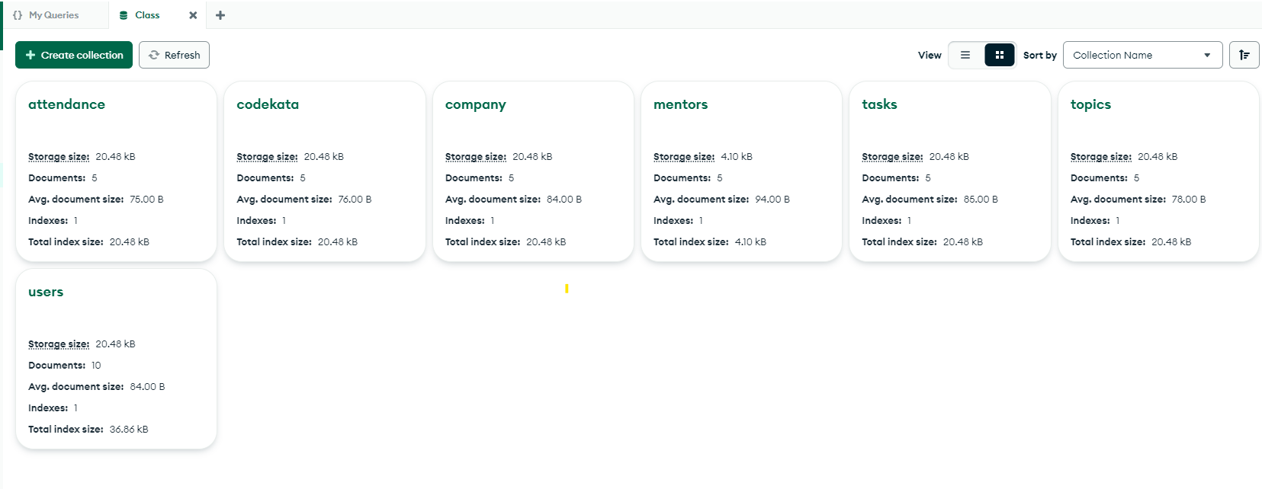

>use Class

<switched to db Class

db.users.insertMany([

{"user_id":1,"name":"Lim","email":"lim@gmail.com"},

{"user_id":2,"name":"Kim","email":"kim@gmail.com"},

{"user_id":3,"name":"Jim","email":"jim@gmail.com"},

{"user_id":4,"name":"Rim","email":"rim@gmail.com"},

{"user_id":5,"name":"Vim","email":"vim@gmail.com"}

])

db.codekata.insertMany([

{"user_id":1,"problem_solved":10,"date_solved":new Date("2020-oct-02")},

{"user_id":2,"problem_solved":15,"date_solved":new Date("2020-oct-28")},

{"user_id":3,"problem_solved":20,"date_solved":new Date("2020-oct-16")},

{"user_id":4,"problem_solved":25,"date_solved":new Date("2020-oct-05")},

{"user_id":5,"problem_solved":30,"date_solved":new Date("2020-oct-09")}

])

db.attendance.insertMany([

{"user_id":1,"status":"true","date_attended":new Date("2020-oct-02")},

{"user_id":2,"status":"false","date_attended":new Date("2020-oct-04")},

{"user_id":3,"status":"true","date_attended":new Date("2020-oct-18")},

{"user_id":4,"status":"true","date_attended":new Date("2020-oct-20")},

{"user_id":5,"status":"false","date_attended":new Date("2020-oct-22")}

])

db.topics.insertMany([

{"topic_id":1,"topic_name":"HTML","topic_date":new Date("2020-oct-03")},

{"topic_id":2,"topic_name":"CSS","topic_date":new Date("2020-oct-05")},

{"topic_id":3,"topic_name":"Bootstrap","topic_date":new Date("2020-oct-17")},

{"topic_id":4,"topic_name":"DOM","topic_date":new Date("2020-oct-21")},

{"topic_id":5,"topic_name":"Javascript","topic_date":new Date("2020-oct-23")}

])

db.tasks.insertMany([

{"user_id":1,"task_id":1,"topic_date": 5 , "date_solved":new Date("2020-oct-05")},

{"user_id":2,"task_id":2,"topic-date": 4 , "date_solved":new Date("2020-oct-14")},

{"user_id":3,"task_id":3,"topic_date": 2 , "date_solved":new Date("2020-oct-17")},

{"user_id":4,"task_id":4,"topic_date": 3 , "date_solved":new Date("2020-oct-20")},

{"user_id":5,"task_id":5,"topic_date": 1 , "date_solved":new Date("2020-oct-25")}

])

db.company.insertMany([

{"user_id":1,"drive name":"Apple","company_attended":new Date("2020-oct-02")},

{"user_id":2,"drive name":"Amazon","company_attended":new Date("2020-oct-04")},

{"user_id":3,"drive name":"Flipkart","company_attended":new Date("2020-oct-18")},

{"user_id":4,"drive name":"Myntra","company_attended":new Date("2020-oct-20")},

{"user_id":5,"drive name":"Google","company_attended":new Date("2020-oct-22")}

])

db.mentors.insertMany([

{"mentor_id":1,"name":"Jay","email":"jay@gmail.com","mentee_count":10},

{"mentor_id":2,"name":"Kay","email":"kay@gmail.com","mentee_count":13},

{"mentor_id":3,"name":"Tay","email":"tay@gmail.com","mentee-count":17},

{"mentor_id":4,"name":"Ray","email":"ray@gmail.com","mentee_count":20},

{"mentor_id":5,"name":"Zay","email":"zay@gmail.com","mentee-count":25}

])

**SOLUTIONS:**

**Find all the topics and tasks which are thought in the month of October**

1. db.topics.find({

"topic_date": {

$gte: new Date("2020-10-01"),

$lte: new Date("2020-10-31")

}

})

db.tasks.find({

"date_solved": {

$gte: new Date("2020-10-01"),

$lte: new Date("2020-10-31")

}

})

**Find all the company drives which appeared between 15 oct-2020 and 31-oct-2020**

2. db.company.find({

"company_attended": {

$gte: new Date("2020-10-15"),

$lte: new Date("2020-10-31")

}

})

**Find all the company drives and students who are appeared for the placement.**

3. db.company.aggregate([

{

$lookup: {

from: "users",

localField: "user_id",

foreignField: "user_id",

as: "student_info"

}

}

])

**Find the number of problems solved by the user in codekata**

4. db.codekata.aggregate([

{

$group: {

_id: "$user_id",

total_problems_solved: { $sum: "$problem_solved" }

}

}

])

**Find all the mentors with who has the mentee's count more than 15**

5. db.mentors.find({

“mentee_count” : {$gt:15}

})

(or)

db.mentors.aggregate([

{$match:{“mentee_count” : {$gt:15}}}

])

**Find the number of users who are absent and task is not submitted  between 15 oct-2020 and 31-oct-2020**

6. db.users.aggregate([

{

$lookup: {

from: "attendance",

localField: "user_id",

foreignField: "user_id",

as: "attendance"

}

},

{

$lookup: {

from: "tasks",

localField: "user_id",

foreignField: "user_id",

as: "tasks"

}

},

{

$match: {

$and: [

{ "attendance": { $not: { $elemMatch: { status: "true", date_attended: { $gte: new Date("2020-10-15"), $lte: new Date("2020-10-31") } } } } },

{ "tasks": { $not: { $elemMatch: { date_solved: { $gte: new Date("2020-10-15"), $lte: new Date("2020-10-31") } } } } }

]

}

},

{

$count: "total_users"

}

]);